Project Title
  - Author 1, Author 2, …

Abstract
Summarize your project in one paragraph (150 words). Include the motivation, proposed solution, and results. This document must be 2-6 pages, excluding references (see the posted guideline).

Introduction
Why the work is relevant? What are the current practices/solutions? What are the challenges? How are you addressing these challenges (briefly)? How are you evaluating your solution?

Related Work
Have other attempted to address the issue you are trying to mitigate? What are these solutions (describe the solution and results from evaluation in a few lines)? Cite the papers, articles, websites, and reports that proposed the solutions, such as [1, 2]. What are the limitations of these solution?

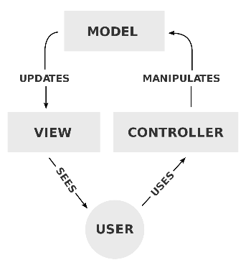
Motivation
Figure 1. Diagram of interactions within the MVC pattern. From https://en.wikipedia.org/wiki/model–view–controller
What motivated the project? Articulate on the reasons mentioned in the “Introduction”.

Design
How did you design the system? Which human and system factors did you consider? Justify all design decisions (based on current practices, existing literature, or pilots/mockups). How does your design is tailored for the target user groups of the product? Clearly describe your solution. Assume that the reader has no prior knowledge of the area. Use diagrams and images, as appropriate (Figure 1).

Implementation
How did you implement the software or hardware? Which development platforms, programming languages, and libraries were used?

Evaluation
What are you evaluating and why? Are you trying to test a hypothesis? Such as,
H₁. Technique 2 improves performance in terms of target selection time.

Apparatus
The hardware and software used in the study. This includes desktop and laptop computers, smartphones, along with specs (brand, dimension, screen size, etc.), when applicable, and development details.

Participants
How did you recruit participants? Their demographics and experience with the examined domain and platform.

Design
What are the independent and dependent variables? What are the levels? Did you use a within- or between-subjects design? Did you counterbalance the conditions?

Procedure
What happened in the study? Where was it conducted? Were there demonstrations and practice blocks? What instructions were given to participants? Were there breaks between the conditions?

Metrics
List all metrics you calculated in the study. Explain how they were calculated.

Results
Presents results of the study statistical analysis and descriptive statistics, as appropriate. Include figures of averages, along with standard deviations.

Discussion
What do the results mean? What are the implications? Can they be generalized? What do we learn from the results? Do they inform the design and development of future systems? Can they influence practices?

Future Work
What are the limitations of the work? How are you planning on addressing these limitations in future studies? How can you extend the work in future research?

References
- Author Name. Year. Title. Publication. Publisher, Pages. DOI
- Author Name. Year. Title. Publication. Publisher, Pages. URL
- Mendeley - Reference Management Software & Researcher Network. Retrieved October 4, 2018 from https://www.mendeley.com

